Section 5375.APPENDIX A Organization Chart

ILLINOIS STUDENT ASSISTANCE COMMISSION

ORGANIZATION CHART

COMMISSION
EXECUTIVE DIRECTOR
MANAGING DIRECTOR, RESEARCH PLANNING AND POLICY ANALYSIS
DIRECTOR, PROGRAM SERVICES AND COMPLIANCE
MANAGING DIRECTOR, COMMUNITY SERVICES
MANAGING DIRECTOR, COLLEGE ACCESS INITIATIVES
DEPUTY EXECUTIVE DIRECTOR
CHIEF FINANCIAL OFFICER
CHIEF MARKETING AND COMMUNICATIONS OFFICER
EXECUTIVE SECRETARY
SECRETARY TO THE COMMISSION
GENERAL COUNSEL
CHIEF INVESTMENT OFFICER
DIRECTOR, INTERNAL AUDIT

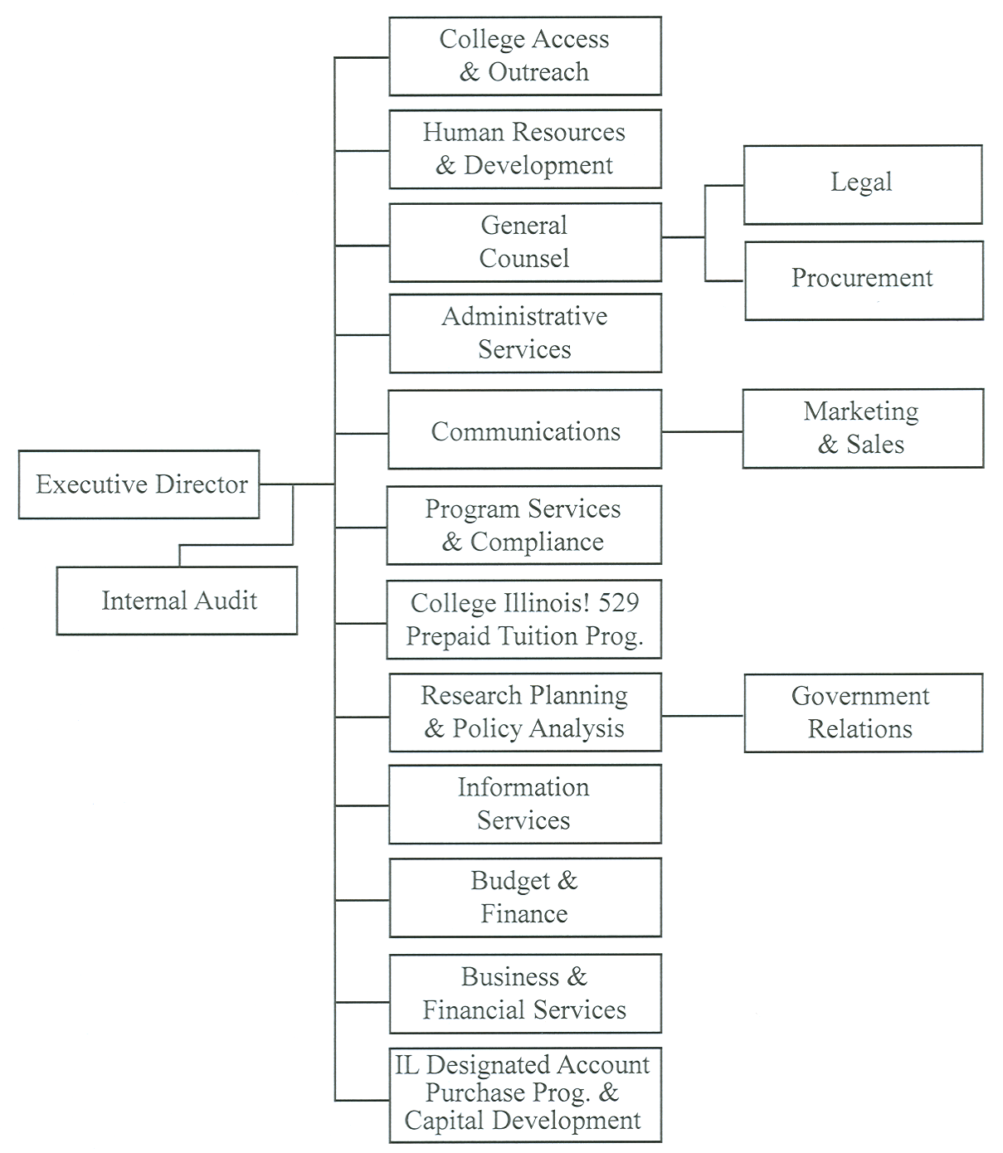

(Source: Amended at 36 Ill. Reg. 5840, effective April 1, 2012)

